Jan Minar
Frederick Li
Computer Systems II (Networks)
30 November 2011

Poor Man’s EBay

Summary
We present two programs written in Java, a client and a server. These programs together implement a client-server protocol which allows people to sell and buy items.

The Protocol
The protocol uses TCP for the main client-server session and UDP for asynchronous message delivery from server to client. It is network-layer agnostic. It has been developed and tested on IPv4.

Main Session
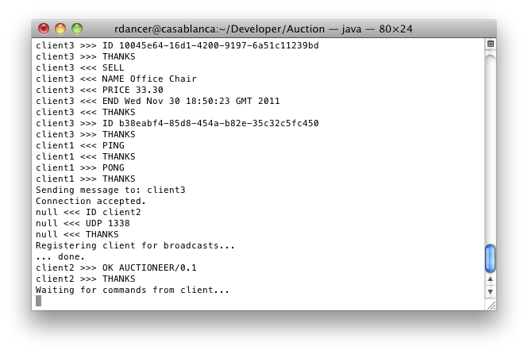
The main part of the protocol comprises of a sequence of client requests and associated server responses. There are. Each request type starts with a special keyword. Each message comprises of two or more lines. A line starts with a keyword, followed by zero or more arguments. The first line of a message specifies the request type. The eight client request types are: HELLO, PING, BROWSE, SELL, BID, CANCEL, CONFIRM, and BYE. The last line starts with the keyword THANKS. The client must start the session with a HELLO request. The session ends when the server receives a BYE request. The session will also end when the TCP connection is reset or times out.
Fig. 1: The server running in a terminal

Asynchronous Messages
Some of the information the server shares with the client does not fit within the paradigm of a sequential request-response model. Some other protocols show many approaches are possible: The POP3 protocol uses polling, the IMAP protocol uses unsolicited server responses. We have chosen to use a separate communication channel and send unsolicited information via UDP. The message format is identical to the request format described above. There is only one message type: ALERT.

Course Requirements and Assessment Criteria
- The number of connections the server can handle is virtually unlimited, constrained by the hardware performance and the Java threading architecture.
- The server keeps in memory the list of auctions, both active and expired. An improved version of the server would use persistent storage such as an SQL database to store this data.
- Client places an item for sale using the SELL request. The server replies with the auction identifier or with an ERROR if listing the item was unsuccessful. This request corresponds to the sell command in the client program.
- When the client sends the BROWSE request, the server replies with a listing of all the items it tracks. This request corresponds to the browse command in the client program.
- The client can remove an item by sending a CANCEL message. The server sends back a random 128-bit token. When the server receives a CONFIRM message containing this token, the cancelation is performed. The server checks that the CANCEL message comes from the item’s seller. However, the CONFIRM message does not need to be checked: Provided that the token is truly random, it cannot be forged. This feature of the protocol can be leveraged to extend the protocol to do other asynchronous commands in a similar manner. These requests is implemented by the cancel command in the client program.
- The server runs a separate thread which checks periodically for expired items and sends an asynchronous ALERT message to both the seller and the winning bidder (if any). The client program will display all alerts it receives from the server.

Limitations
While this protocol would support client authentication, we have not implemented it because we feel that the complex issues of privacy and security are beyond the scope of this project. An encryption layer such as SSL can be readily layered under this protocol to provide such features.

Setup and Use
Along with the source code, two compiled Java classes are provided: one each for the client and the server. Both need to be run with command-line arguments specifying the basic networking and protocol settings. Full IP connectivity between server and clients is necessary — in particular, the client must be able to establish a TCP connection to the server, and the server must be able to send UDP packets to the client. The programs will not attempt to traverse NAT or test for firewalls, as these complex issues are beyond the scope of this assignment.

Starting the Server
Run the server from the command line. You can specify the TCP port number the server should listen on:
java Server [PORT_NUMBER]
For example, to have the server listen on TCP port 1337 (the default), run the server like this:
java Server 1337
The server provides copious console output, printing all the exchanges it shares with clients, as well as other useful information.

Starting the Client
java Client <HOST> <PORT> <CLIENT_ID>
For example, to connects to TCP port 1337 on the local host, with an identifier “bidder2”, run as:
java Client localhost 1337 bidder2

Using the Client
The command-line interface provides integrated help facility the user can access by typing “help”. The verbosity level is turned down by default. To appreciate the client-server communication, the verbosity level can be increased by typing “verbose”.

Improvements
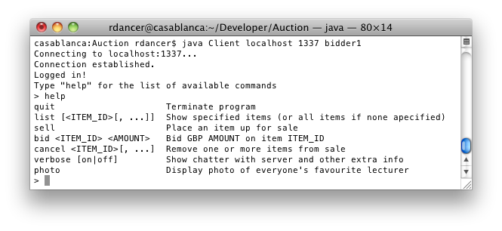
The protocol would benefit from authentication (so that server would establish that the client is who it says it is). This can be readily implemented by requiring the client to supply a shared secret or pass phrase during the session establishment phase, alongside its ID. The server would then check its database of identifier-secret pairs, and only allow the session to proceed if the secrets match. The question of key management arises: how do the client and the server agree on the shared secret in the first place? One of the options would be to used systems where a trusted notary (or a certification authority) brokers this transaction. We could use SSL as a security as well as authentication level.
Fig. 2: The client waiting for input
Currently, the server keeps all the information about items and clients in memory. This is sub-optimal, as a server failure or simply a restart means all this information is lost. Persistent storage, for example an SQL database could be used to persist data across invocations.
The UDP messages sent from server to client will not be delivered if the client is behind a NAT. Further development would ensure that NAT traversal is implemented — Universal Plug and Play could be used.

Public Domain Source Code
No third-party source code used.

References and Bibliography
Postel, J: “Internet Protocol,” RFC 760, USC/Information Sciences Institute (1980)
Postel, J: “Transmission Control Protocol,” RFC 761, USC/Information Sciences Institute (1980)
Postel, J: “User Datagram Protocol,” RFC 768, USC/Information Sciences Institute (1980)
Myers, J & Rose, M: “Post Office Protocol - Version 3,” RFC 1939 (1996)
Bradner, S: “Key words for use in RFCs to Indicate Rqeuirement Levels,” RFC 2119 (1997)
Gosling, J & Joy, B & Steele, G & Bracha, G: The Java Language Specification 3/e, Addison-Wesley (2005)

